**DAILY ONLINE ACTIVITIES SUMMARY**

|  |  |  |  |  |  |  |  |  |
| --- | --- | --- | --- | --- | --- | --- | --- | --- |
| **Date:** | **30/05/2020** | | | | | **Name:** | **PRANEETA P HANDRAL** | |
| **Sem & Sec** | **4thSEM. & ‘B’ SEC.** | | | | | **USN:** | **4AL19CS401** | |
| **Online Test Summary** | | | | | | | | |
| **Subject** | | **DATA COMMUNICATION** | | | | | | |
| **Max. Marks** | | **30** | | **Score** | | | **24** | |
| **Certification Course Summary** | | | | | | | | |
| **Course** | **Python for Machine Learning** | | | | | | | |
| **Certificate Provider** | | | **Greatlearning Academy** | | **Duration** | | | **5 Hrs.** |
| **Coding Challenges** | | | | | | | | |
| **Problem Statement:** Write a C Program to count Uppercase, Lowercase, special character and numeric values for a given String. | | | | | | | | |
| **Status: Executed.** | | | | | | | | |
| **Uploaded the report in Github** | | | | | **Yes** | | | |
| **If yes Repository name** | | | | | **LockdownCoding** | | | |
| **Uploaded the report in slack** | | | | | **Yes** | | | |

**Online Test Summary:** **18CS46 test was scheduled from 9:15 am to 10:00 am. The portion for the IA was 3rd and 4th module there were 30 questions and the time assigned was 45 minutes the questions were mcq type. There were 30 questions of 1 marks respectively.**

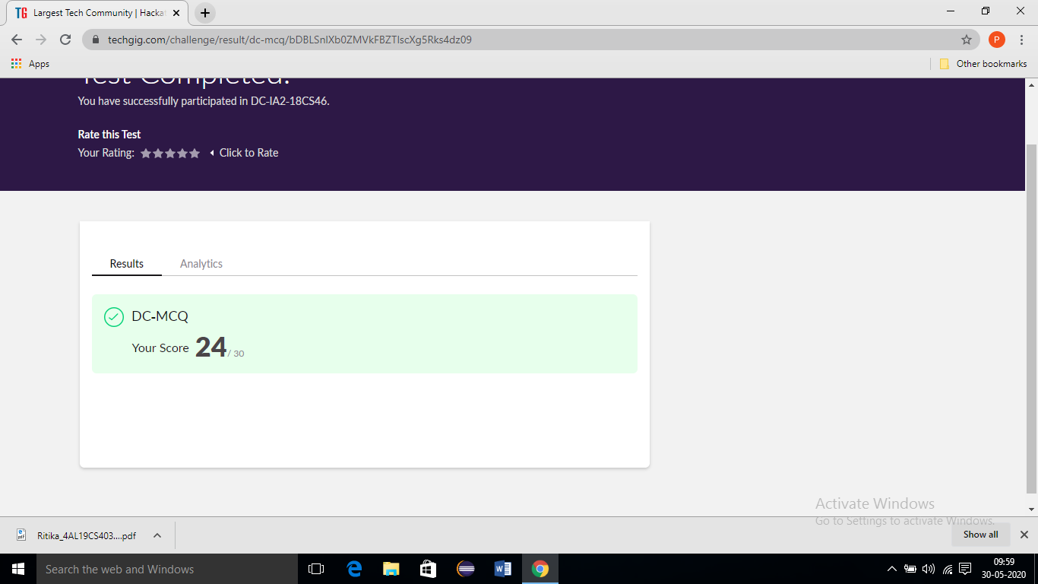

**Online Certification Course Summary:** **Today I have learn about some other Pandas - Combining Dataframes and also execute the some of the basic function programs**

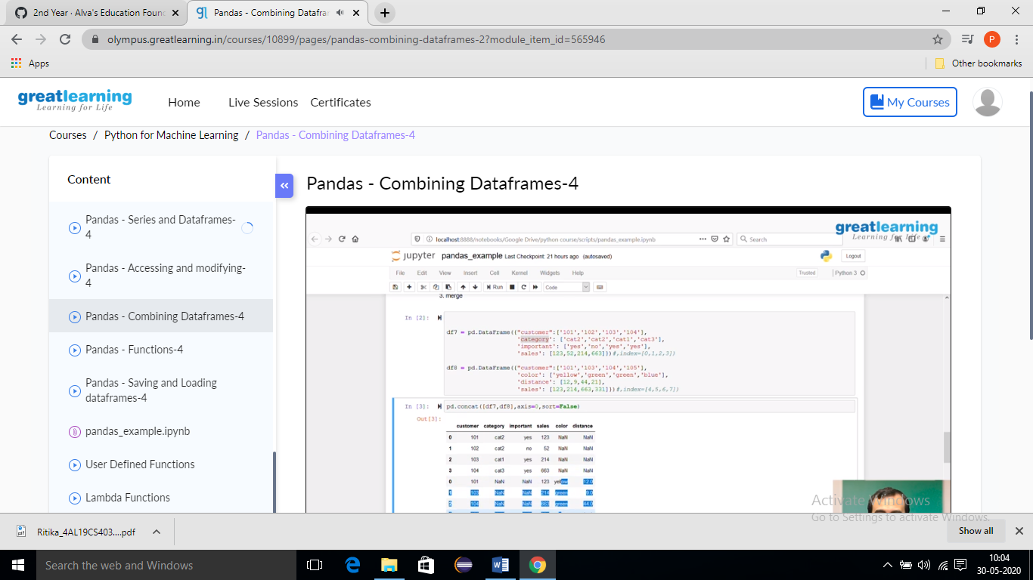

**Online Coding Summary: Today I received one program from Prof. shilpa CSE Dept. The program is mentioned above. to my GitHub repository and I’ve shared the snapshot below.**

